Rerenga Awa | Canterbury Youth Workers Collective Governance Committee (Board)

Thanks for considering being on the board of Rerenga Awa | Canterbury Youth Workers Collective.
Below is a bit of an outline of board member responsibilities and roles.

The images below give a good overview of the Role and function of boards.

In general board meetings are once a month -currently the last Friday of the month 7:30-9:30am, (but this will be revisited once the new board is set at the upcoming AGM.)
Then every couple of months there may be extra things that come up that sub committees are pulled together for. This has happened 1-2 times in the last year, or individuals may offer support to staff for areas they have expertise or special interest in.
The secretary would spend time on finances each month 1-2hrs, and the board chair would meet with me monthly in the lead up to the next board meeting.

Structure of Rerenga Awa
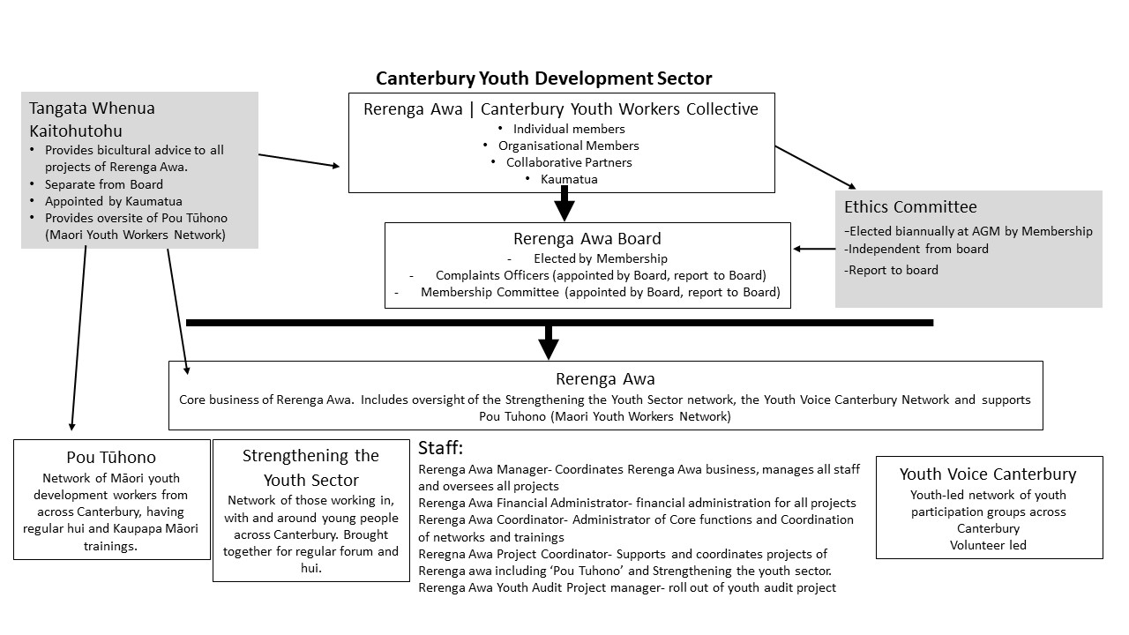

Board Member Overview
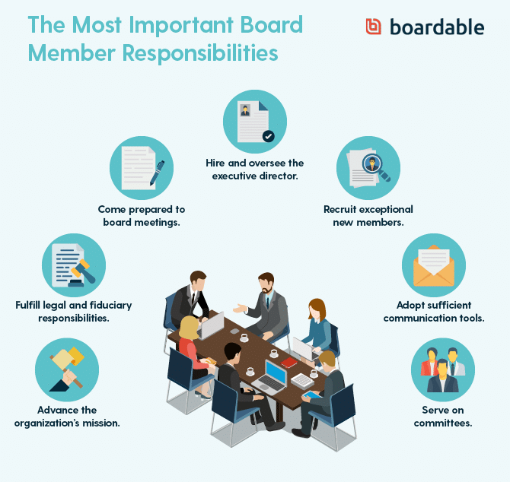
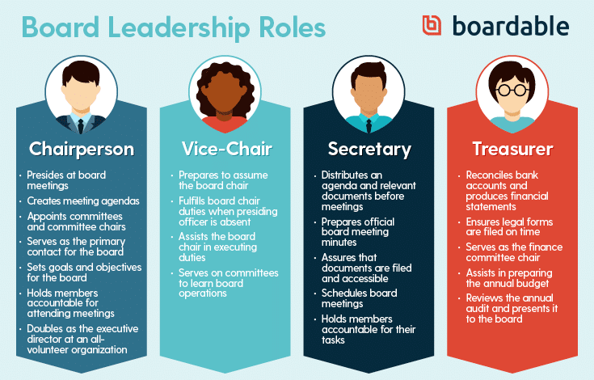
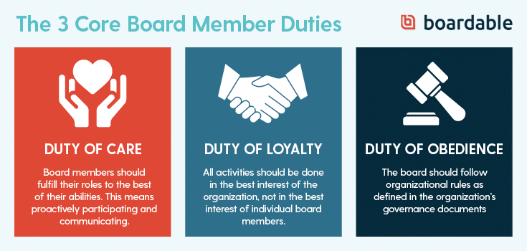

Board Members

Function
The Board is the governing body for Canterbury Youth Workers’ Collective (Rerenga Awa).

Board Members act in a position of Trust for the community and are responsible for the effective governance of the Organisation.

Accountability
Board Members are accountable to members of the Rerenga Awa, funders and the youth sector in Canterbury.

Responsibilities:
In collaboration with other Board Members:
- Sets the vision, mission and values of the Organisation and makes them clear to all members and employee(s) of the Organisation.
- Regularly reviews the values of the Organisation to ensure that what it is attempting to achieve remains both relevant and aligns with the values.
- Communicates with members and stakeholders to ensure that they have input into the determination of direction and goals and to keep them informed about the organisation’s performance.
- Ensure the good standing of the organisation within the community and youth work sector.
- Develops policies and structures which ensure that the functions of the Organisation are fulfilled and the service provided is efficient and effective.
- Develops and expand services on the basis of clearly identified needs.
- Assists in developing and maintaining positive relations among the Board, committees, staff members and the community to enhance the organisation’s mission.
- Attends and participates in all Board and committee meetings and functions.
- Reviews agendas and supporting materials prior to Board and Committee meetings.
- Stays informed about sub-committee matters, prepares themselves well for meetings and reviews and comments on minutes and reports.
- Ensures the accuracy of monthly meeting contents.
- Sits on at least one sub-committee and participates actively in committee work.
- Volunteers for and willingly accepts and completes assignments on time.
- Is an active participant in the Board’s annual evaluation and planning efforts.
- Votes on, where appropriate, policy and other recommendations received from the Board, its standing committees and employees.
- Monitors and develops all Board policies and sets strategic direction for the organisation.
- Ensure adequate resources and their effective management including money, people, facilities and equipment.
- Acts as a good employee of paid and unpaid staff.
- Deals with any complaints laid against the Organisation of staff.
- Defines the Organisation’s legal and constitutional framework and its purpose, direction and priorities. Complies with all legal and contractual requirements placed on the Board and seeks legal advice to stay up to date with what these are.
- Assists the Boards in carrying out its fiduciary responsibilities such as reviewing the Organisation’s annual financial statements and approving the annual budget.
- Suggests possible nominees to the Board who can make significant contributions to the work of the Board and the Organisation.
- Nominates and elects Board members to officer positions annually or at the resignation of the position holder.
- Continually evaluates own performance as well as the performance of the Board.
- Follows conflict of interest and confidentiality policies.
- Refrains from making special request of the staff or volunteers.
- Adheres to Code of Conduct and organisational policies.

Person Specification
Someone who possesses:
- Honesty and is reliable, trustworthy and conscientious
- Sensitivity to, and tolerance of differing views
- A friendly, responsive and patient approach
- Community-building skills
- Personal integrity
- A developed sense of values
- A sense of humour
- The ability to listen, analyse and think clearly and creatively
- The ability to work well with people individually and in a group
- Knowledge of the Organisation, its goals and direction
- A willingness to prepare for and attend all meetings, ask questions, take responsibility and follow through on a given assignment.
- A willingness to develop new skills such as to: cultivate and solicit funds, cultivate and recruit Board members and other volunteers, read and understand financial statements, lean more about the programme area of the Organisation.

Term of Service
Board members are elected by the membership at the Annual General Meeting.
Board Members serve for a one-year term.

Time Commitment (average per month)

- Monthly Board meetings 2 hours
- Special Board meetings 1 hour
- General 2 hours
Total: 5 hours

Orientation
Orientation will be provided by the incoming Chairperson.

Chairperson

Function:
The Chairperson needs to facilitate effective meeting outcomes, be aware of developmental issues facing the Board as a group, lead and create a safe environment in which members make an optimal contribution and keep the Board focused on its task.

Specific responsibilities:
- Building an effective team
- Be the key link person between Board and staff
- Serve as ex-officio members of all committees
- Work in partnership with key staff to make sure Board resolutions are carried out.
- Call special meetings if necessary
- Appoint all committee chairs and, with key staff recommend who will serve on committees
- Assist key staff in preparing agenda for Board meetings
- Assist key staff in conduction new Board member orientation
- Oversee searches for key staff
- Coordinate key staff annual performance evaluation
- Work with other Board/staff to recruit new Board members
- Coordinate periodic Board assessments with the key staff
- Act as an alternate spokesperson for the organisation particularly on political and policy matters.
- Periodically consult with Board members on their roles and help them assess their performance.
- Ensure that individual trustees do not act independently of the Boards decisions.

Secretary

Function:
The Secretary is the chief administrative officer of the organisation and should be capable of working closely and amicably with the Chairperson. He/she should also have a good eye for detail, be a good organiser and meticulous in keeping records.

Specific responsibilities:
- Attend all Board meetings
- Serve on the Executive Committee
- Maintain all Board records and ensure their accuracy and safety
- Review Board minutes
- Assume responsibilities of the Chairperson in the absence
- Provide notice of meetings of the Board and/or of a committee when such notice is required.
- Provide notice of other events as required.

Treasurer

Function
The Treasurer is responsible for the handling of monies- including the payment of tax returns, issuing of receipts and planning budgets. Where tasks are delegated to paid staff, extra care should be taken in certifying the records.

Key skills and responsibilities:
- Knowledge of the Organisation and personal commitment to its goals and objectives
- Understanding of financial accounting for non-profit organisations
- Serve as financial officer of the Organisation and as Chairperson for the financial committee
- Manages with the finance committee, the Boards review of and action related to the Boards financial responsibilities
- Works with key staff to ensure that appropriate financial reports are made available to the Board on a timely basis
- Assists key staff in preparing the annual budget and presenting the budget to the Board for approval
- Ensures annual accounts are prepared in a timely and efficient manner
- Reviews the annual audit and answers Board member’s questions about the audit.

Specific duties:
- Preparation of a budget based on information from previous years and plans for the upcoming year (for new organisations leave room for error).
- The budget is presented to the first general committee meeting for adoption as the financial target of the year, aiming for a surplus.
- If the Treasurer is given authority to pay accounts without committee approval, a list of payments is reported to the next meeting and endorsed.
- At regular committee meetings, the treasurer reports financial results with a brief comparison of how the situation compares with the budget. If it differs widely, Treasurer should make this clear and suggest alternatives.
- The Treasurer is responsible for supervising the collection of all receipts.
- For special functions, separate budget may need to be prepared.
- The Treasurer checks monthly (or more regularly, where appropriate) bank statements and checks against records
- An independent audit is required in addition to good internal checking.
- All online payments require 2 signatories to approve.

